Dependency Inversion Principle (DIP) Violations
- DIP001 — Constructor depends on a concrete class
Description: a violation occurs when a class constructor (__init__) depends on a concrete class instead of an abstraction.
Why this is a problem: Because High-level modules should not depend on low-level implementations. Both should depend on abstractions
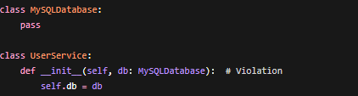
Example (Violation) :

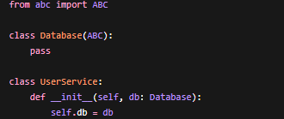
Correct Approach:

- DIP002 — Method depends on a concrete class

Description: A violation occurs when a method (other than the constructor) accepts a concrete class as a parameter
Example (Violation):


Correct Approach:

DIP003 — Direct instantiation of a concrete class
Description:
A violation occurs when a class directly creates (instantiates) a concrete class inside its methods.

Example (Violation):

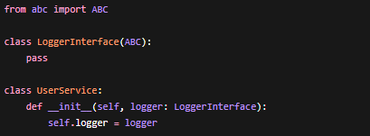
Correct Approach:

DIP004 — Attribute depends on a concrete class
Description:
A violation occurs when a class attribute is annotated with a concrete class type
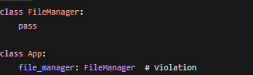
Example (Violation):


Correct Approach:

DIP005 — Inheriting from a concrete class
Description: A violation occurs when a class inherits from a concrete class instead of an abstraction.

Example (Violation):

Correct Approach:



DIP006 — Method returns a concrete class
Description: A violation occurs when a method returns a concrete class type.
Example (Violation):
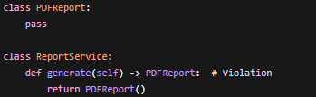

Correct Approach:
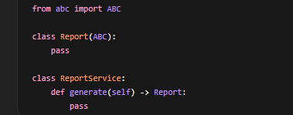

All dependencies in the system should follow this rule:
- Do not depend on concrete classes
- Depend on abstractions (interfaces or abstract classes) instead

